**PROJECT 2 – NETFLIX CLONE(HTML&CSS)**

**Hello,I am Himanshu kumar .i created a netflix clone project**

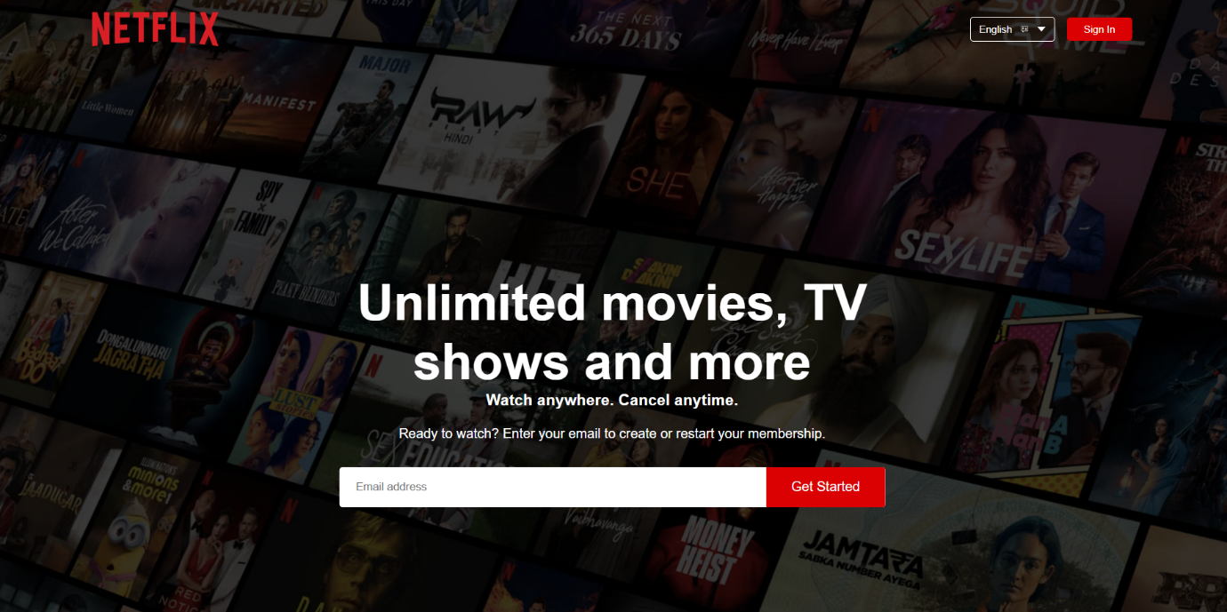**Using html and css.**

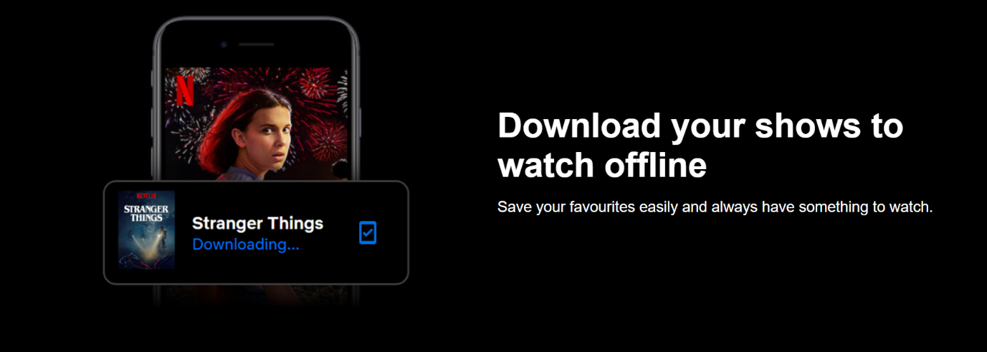

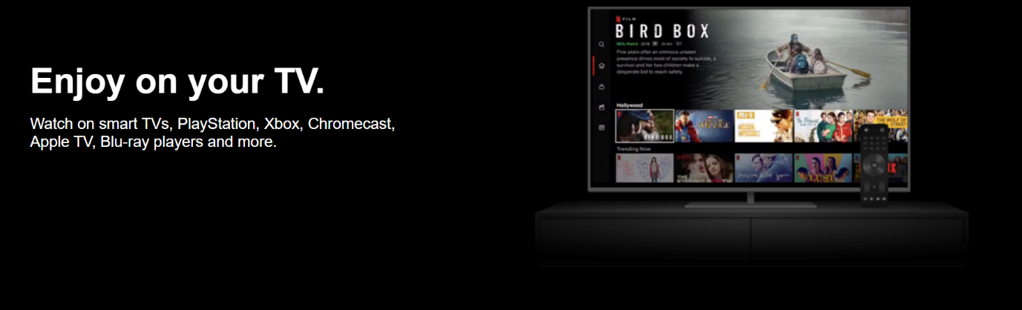

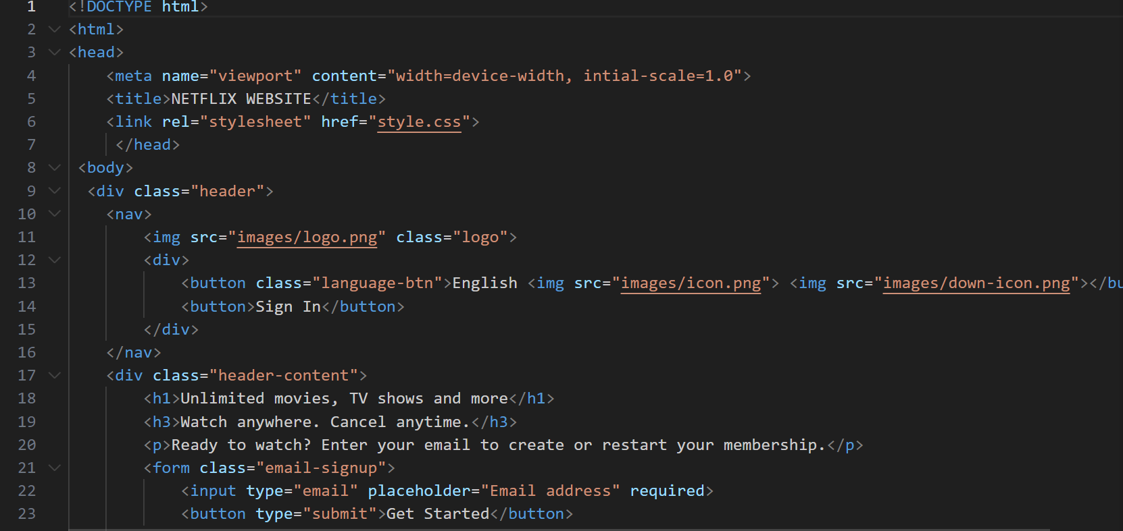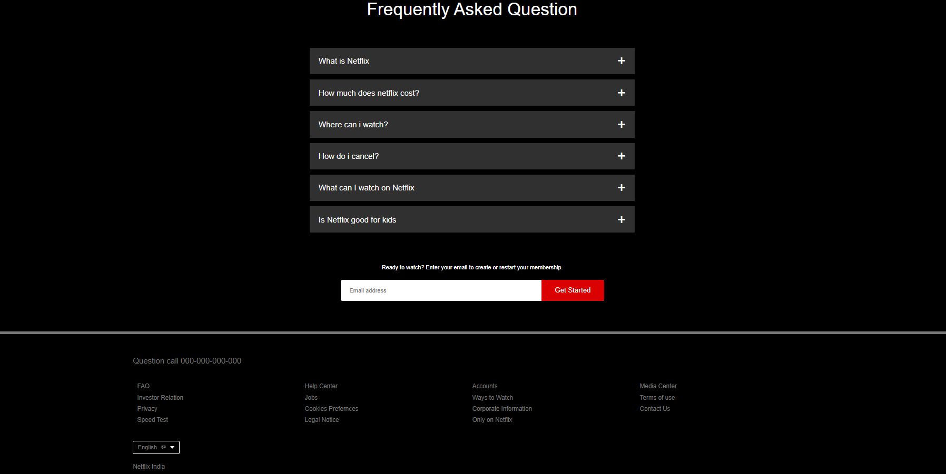**HTML CODE**

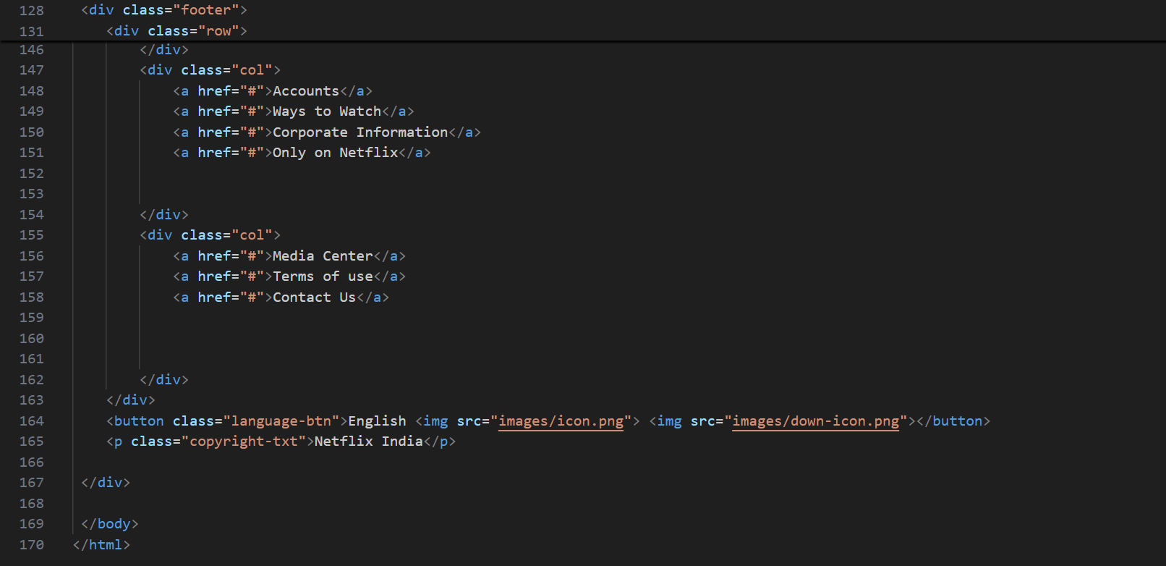

**CSS CODE**

